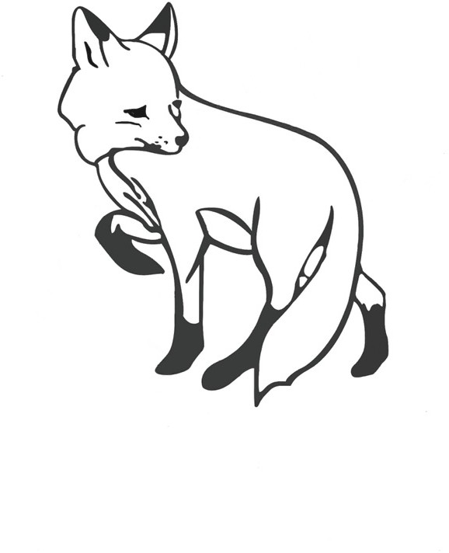The Fox Project

Southern Wildlife Ambulance Network - Reg charity no. 1190070

**Standing Order Authority**

Name of your bank: __________________________________________________________

Branch title: ________________________________________________________________

Address of your bank: ________________________________________________________

___________________________________________________________________________

___________________________________________________________________________

Account title: _________________________________________________________________

Your account No. : ____________________________

Sort Code: ________________________

Please pay the sum of £ __________ (Pounds _____________________)

from the above account on the ___________ day of each month/year commencing

____________________

To: Charities Aid Foundation, 25 Kings Hill Avenue, Kings Hill, West Malling, ME19 4TA

For the credit of: The Fox Project (Southern Wildlife Ambulance Network), CAF Cash Account No. 00035475 Sort Code: 40-52-40

Signed: _________________________________________

Dated: _______________________________

**Gift Aid Declaration**

**Are you a UK taxpayer?**

**Gift Aid boosts your donation by a further 25p for every £1 you donate!**

**Gift Aid? Yes/No**

I wish to Gift Aid any donation shown here and any donations I make in the future or have made in the past 12 months to Southern Wildlife Ambulance Network / The Fox Project (charity no: 1190070).

Title: Name: Your Address:

Email Address: Mobile:

Communication Preference (please mark your preferred method):

Email



Postal



Signed: Dated: